1. Identify stakeholders

“A stakeholder is an individual, group, or organization that may affect, be affected by, or perceive itself to be affected by a decision, activity, or outcome of a project.”( Project Management Institute, (2017)

Being the market leader in the automotive industry, stakeholder for Turners will be quite vast. Not only do they provide the conventional dealership role but also has in-house financing and business insurance. These two division, will overlap each other in terms of stakeholders. Their stake holder can be internal and external which includes:

Internal stakeholders:

* Employee
  + Customer service representative
  + Internal underwriter
* Managers
  + Product manager
  + Sales manager
* Owners

External stakeholders:

* Customers
* End users
* Suppliers
* Shareholders
* Government
* Competitors
* Creditors
* Society

These stakeholders are specific to the insurance.

1. Understand context of a project

From the standpoint of someone who haven’t yet created a chatbot the most important thing to know is **what technology or tools can I use to complete the project**. Is it easy to learn if I don’t know it? Are there alternative they provide the same results?

Secondly, How much autonomy does the team have in completing their work?

Thirdly, What areas should the team focus on the most for this particular project?

Fourthly, What are the primary objectives and goals for this specific project?

And Lastly, 5. What are the best assets to leverage for this project?

1. Designing the Chat Bot

* Auction or bidding Flow

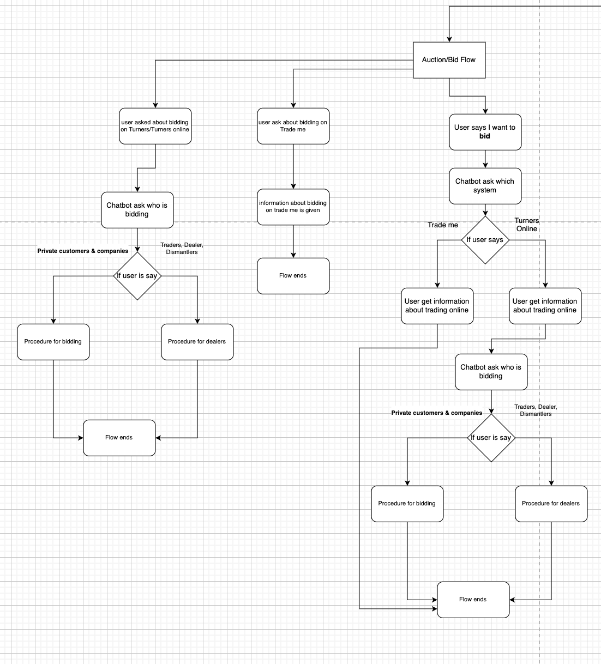

* Account

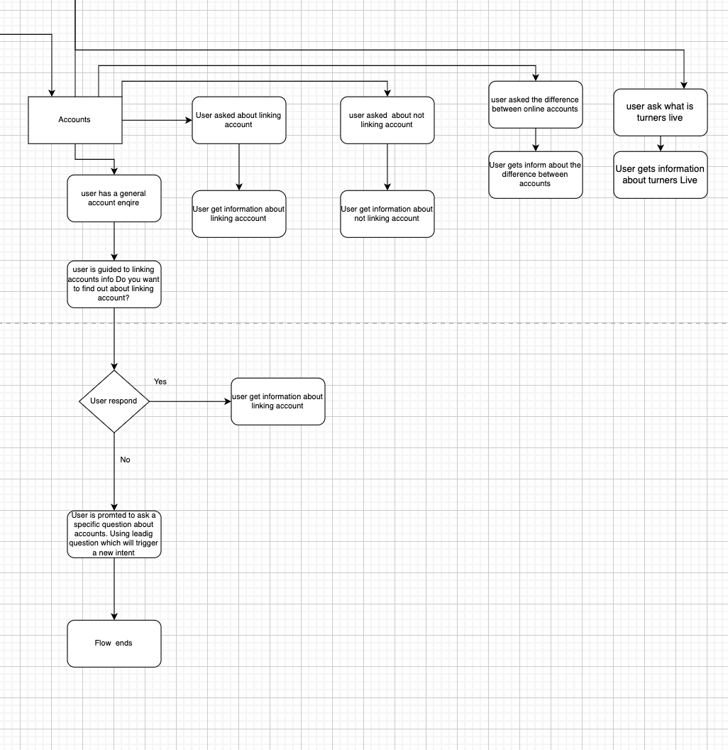

* Autobid

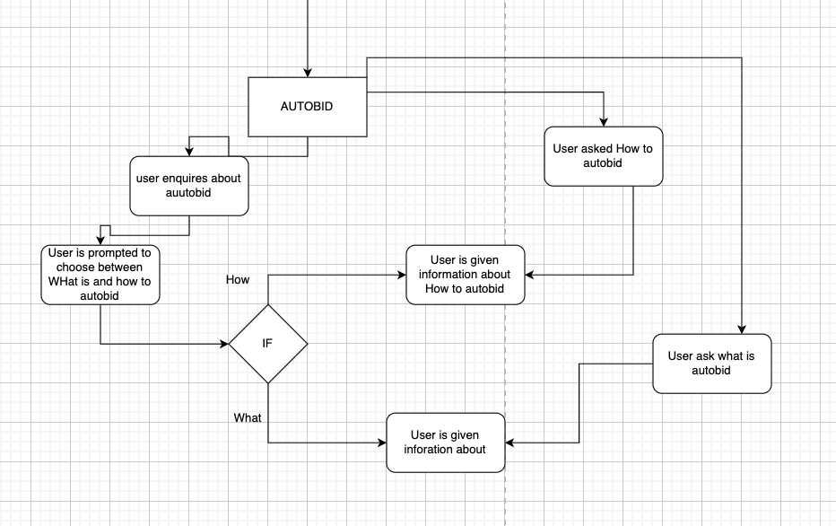

* Others

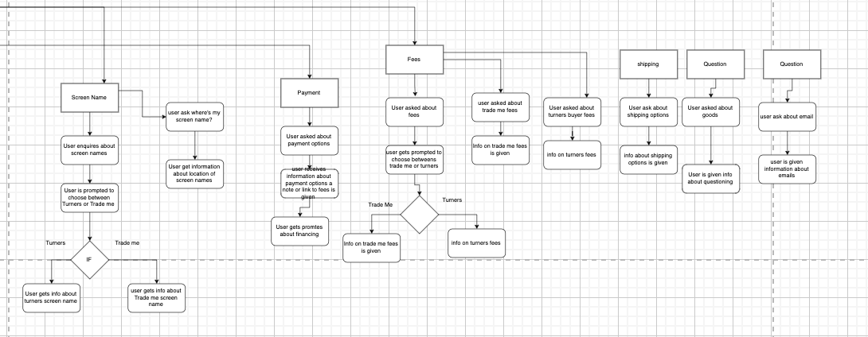

Reference:

Project Management Institute. (2017). *A guide to the Project Management Body of Knowledge (PMBOK guide)* (6th ed.). Project Management Institute.

tutor2u. (2018, March 5). Stakeholders and Stakeholder Mapping Explained [Video]. YouTube. https://www.youtube.com/watch?v=gc55hPIFW8w